**Q1. WHAT ARE THE DIFFERENT WAYS TO CREATE DATABASE IN SQL SERVER?**

**Option 1 : Using GUI**

**Right Click Database > New Database**

**Option 2 : Using T-SQL Script**

**Right Click Server > New Query :**

**CREATE DATABASE <DATABASENAME>**

**Q2. HOW DO YOU VERIFY IF THE DATABASE IS CREATED SUCESSFULLY?**

**RIGHT CLICK SERVER FROM SSMS > REFRESH.**

**EXPAND DATABASES > WE SEE THE LIST OF DATABASES.**

**Q3. WHAT IS A SESSION?**

**EVERY QUERY WINDOW IS CALLED A SESSION.**

**FOR THIS, YOU NEED TO RIGHT CLICK THE SERVER > NEW QUERY.**

**Q4. HOW DO YOU VERIFY THE SESSION ID?**

**WE SEE THIS SESSION ID (SESSION NUMBER) BESIDE THE SESSION PANE:**

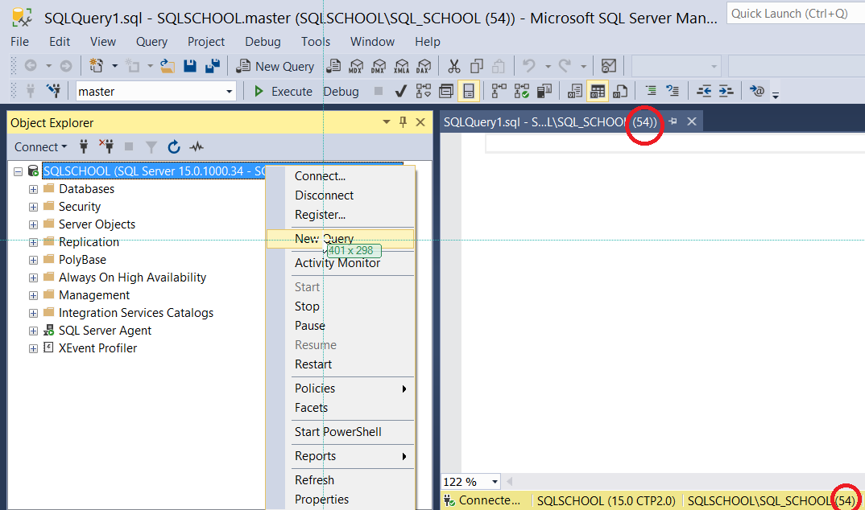

**Q5. CAN YOU CREATE MULTIPLE DATABASES IN PARALLEL?**

**NO, WE CANNOT.**

**Q6. WHAT IS THE USE OF MODEL DATABASE?**

**MODEL DATABASE WILL BE A TEMPLATE FOR NEW DATABASES WE CREATE.**

**Q7. WHAT IS THE USE OF RESOURCE DATABASE?**

**RESOURCE DATABASE IS USED TO CONTROL THE MASTER DATABASE AND SQL SERVER SETUP FILES.**

**Q8. WHICH DATABASE CONTROLS AUTHENTICATION?**

**MASTER**

**Q9. WHAT IS A SESSION?**

**EVERY QUERY WINDOW IS CALLED A SESSION.**

**TO DEFINE A NEW SESSION: RIGHT CLICK SERVER > NEW QUERY**